Tag CSS

id selector “jika di html menggunakan id”
#para1 {
text-align: center;
color: red; }

class selector “jika di html menggunakan class”
.center {
text-align: center;
color: red;
}
“jika element terlebih dahulu dibanding class”
p.center {
text-align: center;
color: red; }

Grouping selector “menselect semua elemnt”
h1, h2, p {
text-align: center;
color: red; }

comment “jika ingin memberikan sebuah komentar”
p {
color: red;
/* This is a single-line comment */
text-align: center;
}
/* This is a multi-line comment */

external style sheet “memberikan tag css dengan file”
<head>
<link rel="stylesheet" type="text/css" href="mystyle.css">
</head>

internal style sheet “memberikan kodingan css dalam html”
<head>
<style>
body {
background-color: linen; }
h1 {
color: maroon;
margin-left: 40px; }
</style>
</head>

<body>
<h1>This is a heading</h1>
<p>This is a paragraph.</p>
</body>
inline styles “kodingan css berada di body atau dalam html”
<h1 style="color:blue;margin-left:30px;">This is a heading</h1>

multiple style sheets “gabungan dari external dan internal style sheets”
<head>
<style>
h1 {
color: orange; }
</style>
<link rel="stylesheet" type="text/css" href="mystyle.css">
</head>

color “cari di google kodingan warna pada css”
color name, RGB, heksadesimal color.

Background-color “warna belakang pada layar text”
body {
background-color: lightblue; }

background-image “warna belakang menjadi sebuah gambar”
body {
background-image: url("paper.gif"); }

background image – Repeat horizontal or vertical “settingan keatas atah sejajar”
body {
background-image: url("gradient_bg.png");
background-repeat: repeat-x; }

background image – set position and no-repeat “gambar berada di dalam kata/kalimat”
body {
background-image: url("img_tree.png");
background-repeat: no-repeat;
background-position: right top;
margin-right: 200px; }

background image – fixed position “gambar tidak bentur denga kata/kalimat”
body {
background-image: url("img_tree.png");
background-repeat: no-repeat;
background-position: right top;
background-attachment: fixed;
margin-right: 200px; }

background -shorthand property “gabungan”
body {
background: #ffffff url("img_tree.png") no-repeat right top;
margin-right: 200px; }

border , macam-macam border : “bentuk pada garis tabel”
p.dotted {border-style: dotted;}
p.dashed {border-style: dashed;}
p.solid {border-style: solid;}
p.double {border-style: double;}
p.groove {border-style: groove;}
p.ridge {border-style: ridge;}
p.inset {border-style: inset;}
p.outset {border-style: outset;}
p.none {border-style: none;}
p.hidden {border-style: hidden;}
p.mix {border-style: dotted dashed solid double;}
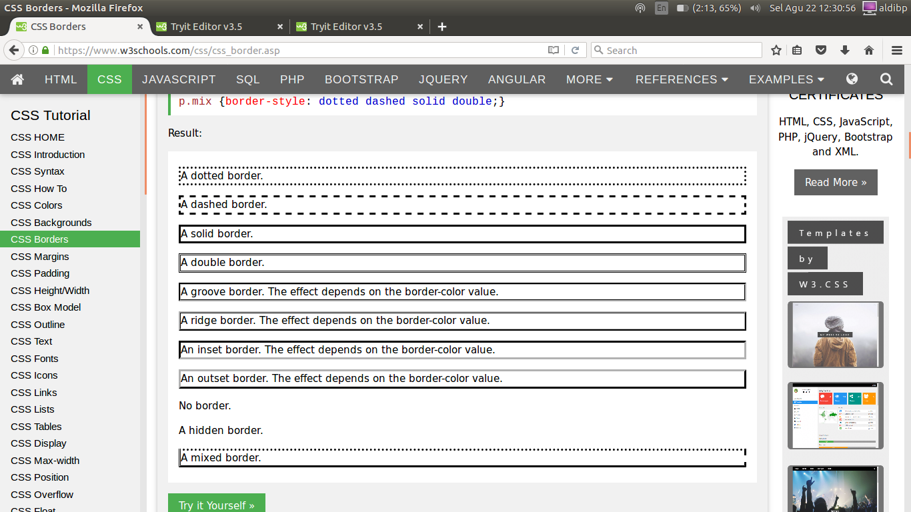

border color “warna pada garis tabel”
p.one {
border-style: solid;
border-color: red; }

border – indivisual sides “bentuk dari atas kanan bawah kiri yang berbeda”
p {
border-top-style: dotted;
border-right-style: solid;
border-bottom-style: dotted;
border-left-style: solid; }

border shorthand sides “gabungan”
p {
border-left: 6px solid red;
background-color: lightgrey; }

p {
border-bottom: 6px solid red;
background-color: lightgrey; }

border – rounded borders “lekukan pada ujung tabel yang berbeda”

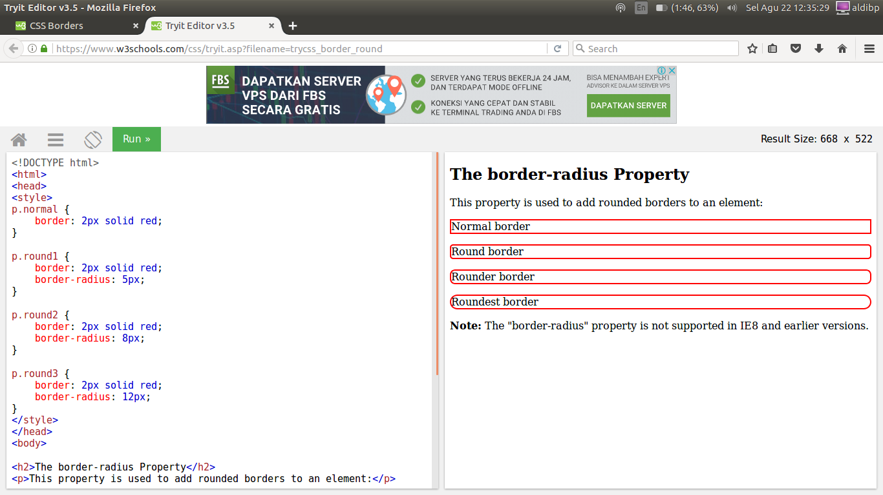
margins “ukuran kertas”
p {
margin-top: 100px;
margin-bottom: 100px;
margin-right: 150px;
margin-left: 80px; }

p {
margin: 100px 150px 100px 80px; }

margins – auto “penyesuaian margin”
div {
width: 300px;
margin: auto;
border: 1px solid red; }

margins – inherit value “di kasih jarak margin”
div.container {
border: 1px solid red;
margin-left: 100px; }
p.one {
margin-left: inherit; }

margins – collaps “jarak pada paragraph”
h1 {
margin: 0 0 50px 0;}
h2 {
margin: 20px 0 0 0;}

padding “jarak dalam pada garis tabel ”
p {
padding-top: 50px;
padding-right: 30px;
padding-bottom: 50px;
padding-left: 80px;
}

padding – shorthand property “gabungan”
p {
padding: 50px 30px 50px 80px;
border: 1px solid black;
background-color: lightblue;
}

height/width “tinggi dan lebar pada layar”
div {
height: 200px;
width: 50%;
background-color: powderblue;
}

Box model “gabungan, awal buat content, padding, border, margin”
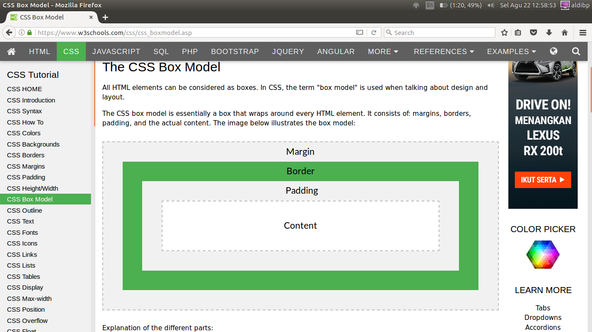
div {
width: 320px;
padding: 10px;
border: 5px solid gray;
margin: 0;
}

Outline “pewarnaan garis pada border”
p {
border: 1px solid black;
outline-color: red;
}
p.dotted {outline-style: dotted;}
p.dashed {outline-style: dashed;}
p.solid {outline-style: solid;}
p.double {outline-style: double;}
p.groove {outline-style: groove;}
p.ridge {outline-style: ridge;}
p.inset {outline-style: inset;}
p.outset {outline-style: outset;}

text “tulisan”
h1 {
text-align: center; }
h2 {
text-align: left; }
h3 {
text-align: right; }
text-align: justify;

text decoration “bentuk garis pada tulisan”
h1 {
text-decoration: overline; }
h2 {
text-decoration: line-through; }
h3 {
text-decoration: underline; }

text transformation “kapital, biasa, awal kata kapital dan seterusnya biasa”
p.uppercase {
text-transform: uppercase; }
p.lowercase {
text-transform: lowercase; }
p.capitalize {
text-transform: capitalize; }

text indentation “awal pada paragraph dikasih jarak 5cm agar rapih”
p {
text-indent: 50px;
}

letter spacing “jarak antar spasi”
h1 {
letter-spacing: 3px; }
h2 {
letter-spacing: -3px; }

line hight “tinggi kalimat”
p.small {
line-height: 0.8; }
p.big {
line-height: 1.8; }

text direction “membalikkan kata/kalimat dibaca dari belakang”
p {
direction: rtl; }

word spacing “jarak kata per kata”
h1 {
word-spacing: 10px;}
h2 {
word-spacing: -5px; }

text shadow “bayangan kata/kalimat”
h1 {
text-shadow: 3px 2px red;
}

Fonts “bentuk bahasa kata”

font family “gaya bahasa tulisan”
p {
font-family: "Times New Roman", Times, serif;}

font style “gaya tuisan”
p.normal {
font-style: normal;}
p.italic {
font-style: italic; }
p.oblique {
font-style: oblique; }

font size “ukuran tulisan”
h1 {
font-size: 40px; }
h2 {
font-size: 30px; }
p {
font-size: 14px; }

font weight “lebar tulisan”
p.normal {
font-weight: normal; }
p.thick {
font-weight: bold; }

links “ngelink”
/* unvisited link */
a:link {
color: red;
}
/* visited link */
a:visited {
color: green;
}
/* mouse over link */
a:hover {
color: hotpink;
}
/* selected link */
a:active {
color: blue;
}

<p><b><a href="default.asp" target="_blank">This is a link</a></b></p>

link- text decoration “ketika di klik aka berubah warna dan lain-lain”
a:link {
text-decoration: none;
}
a:visited {
text-decoration: none;
}
a:hover {
text-decoration: underline;
}
a:active {
text-decoration: underline;
}

link -background color “ketika di klik bankgroud warna berubah”
a:link {
background-color: yellow;
}
a:visited {
background-color: cyan;
}
a:hover {
background-color: lightgreen;
}
a:active {
background-color: hotpink;
}

link button
a:link, a:visited {
background-color: #f44336;
color: white;
padding: 14px 25px;
text-align: center;
text-decoration: none;
display: inline-block; }
a:hover, a:active {
background-color: red; }

List “ordered list dan unordered list”
ul.a {
list-style-type: circle; }
ul.b {
list-style-type: square; }
ol.c {
list-style-type: upper-roman; }
ol.d {
list-style-type: lower-alpha; }

<style>
ul.a {list-style-position:inside;}
ul.b {list-style-position:outside;}
</style>

table – hoverable table “hover”
tr:hover {background-color: #f5f5f5}

table – striped tables “table tiap baris beda warna”
tr:nth-child(even) {background-color: #f2f2f2}
table – table color “dengan striped”
tr:nth-child(even) {background-color: #f2f2f2}
th {
background-color: #4CAF50;
color: white;
}

table – responsive tables “responsive”
table {
border-collapse: collapse;
width: 100%; }

th, td {
text-align: left;
padding: 8px; }

tr:nth-child(even){background-color: #f2f2f2}
</style>

display “telah ditentukan untuk berjalan sebelum di tekan”
li {
display: inline; }
span {
display: block; }
a {
display: block; }
h1.hidden {
display: none; }
h1.hidden {
visibility: hidden; }

max -width
div.ex1 {
width: 500px;
margin: auto;
border: 3px solid #73AD21;
}
div.ex2 {
max-width: 500px;
margin: auto;
border: 3px solid #73AD21;
}

potition static “posisi di sebelah kiri margin”
div.static {
position: static;
border: 3px solid #73AD21;
}
position relative “posisi agak menjarak 1cm pada margin”
div.relative {
position: relative;
left: 30px;
border: 3px solid #73AD21;
}
position absolut “bisa di taro dimana saja”
img {
position: absolute;
left: 0px;
top: 0px;
z-index: -1;
}

overflow visible “box text menyesuaikan titik akhir pada kalimat.
div {
width: 200px;
height: 50px;
background-color: #eee;
overflow: visible;
}

overflow hidden “menghilangkan kalimat”
div {
overflow: hidden;
}
overflow scroll “box kata/kalimat yang bisa di scroll”
div {
overflow: scroll;
}
overflow auto “box kata/kalimat yang bisa si scroll tetapi box nya agak lebih kecil”
div {
overflow: auto;
}

float property “penentuan float gambar “
img {
float: right;
margin: 0 0 10px 10px;
}
float – clear property “penentuan flot untuk memisah pada sebuah tabel”
div {
clear: left;
}
float – the clearfix hack
.clearfix {
overflow: auto;
}

.clearfix::after {
content: "";
clear: both;
display: table;
}

inline – block “jarak garis tabel block”
.floating-box {
display: inline-block;
width: 150px;
height: 75px;
margin: 10px;
border: 3px solid #73AD21;
}

align text “default text”
.center {
text-align: center;
border: 3px solid green;
}

opacity transparant “transparant pada gambar”
img {
opacity: 0.5;
filter: alpha(opacity=50); /* For IE8 and earlier */
}

opacity – transparant hover “transparant di klik”
img {
opacity: 0.5;
filter: alpha(opacity=50); /* For IE8 and earlier */
}
img:hover {
opacity: 1.0;
filter: alpha(opacity=100); /* For IE8 and earlier */
}

opacity – transparant box
div {
opacity: 0.3;
filter: alpha(opacity=30); /* For IE8 and earlier */
}

navigatin bar “liat di google, w3school.com”
menggunakan vertikal maupun horizontal

dropdown menu “memilih list ketik didekatkan”
<style>
/* Style The Dropdown Button */
.dropbtn {
background-color: #4CAF50;
color: white;
padding: 16px;
font-size: 16px;
border: none;
cursor: pointer;
}
/* The container <div> - needed to position the dropdown content */
.dropdown {
position: relative;
display: inline-block;
}
/* Dropdown Content (Hidden by Default) */
.dropdown-content {
display: none;
position: absolute;
background-color: #f9f9f9;
min-width: 160px;
box-shadow: 0px 8px 16px 0px rgba(0,0,0,0.2);
z-index: 1;
}
/* Links inside the dropdown */
.dropdown-content a {
color: black;
padding: 12px 16px;
text-decoration: none;
display: block;
}
/* Change color of dropdown links on hover */
.dropdown-content a:hover {background-color: #f1f1f1}
/* Show the dropdown menu on hover */
.dropdown:hover .dropdown-content {
display: block;
}
/* Change the background color of the dropdown button when the dropdown content is shown */
.dropdown:hover .dropbtn {
background-color: #3e8e41;
}
</style>
<div class="dropdown">
<button class="dropbtn">Dropdown</button>
<div class="dropdown-content">
<a href="#">Link 1</a>
<a href="#">Link 2</a>
<a href="#">Link 3</a>
</div>
</div>

dropdown content “memilih konten ketik di klik”
.dropdown-content {
right: 0;
}

tooltips “ketika di tempel maka muncul kutipan”
<style>
/* Tooltip container */
.tooltip {
position: relative;
display: inline-block;
border-bottom: 1px dotted black; /* If you want dots under the hoverable text */
}
/* Tooltip text */
.tooltip .tooltiptext {
visibility: hidden;
width: 120px;
background-color: black;
color: #fff;
text-align: center;
padding: 5px 0;
border-radius: 6px;
/* Position the tooltip text - see examples below! */
position: absolute;
z-index: 1;
}
/* Show the tooltip text when you mouse over the tooltip container */
.tooltip:hover .tooltiptext {
visibility: visible;
}
</style>
<div class="tooltip">Hover over me
<span class="tooltiptext">Tooltip text</span>
</div>

image gallery “cari di google, w3school.com”

image sprites “cari di google, w3school.com”

attr selectors “cari di google, w3school.com”

forms “cari di google, w3school.com”

Counters “cari di google, w3school.com”

